**Name**: Khushei Meghana Meda

**SRN**: PES1201800416

**Week number**: 5

**Name of experiment**: Simple Client-Server Application using Network Socket Programming

**Date**: 19-10-2020

**Objectives of the experiment**: To develop a simple Client-Server application using TCP and UDP.

Pre requisites:

Client IP: set to 10.0.6.11

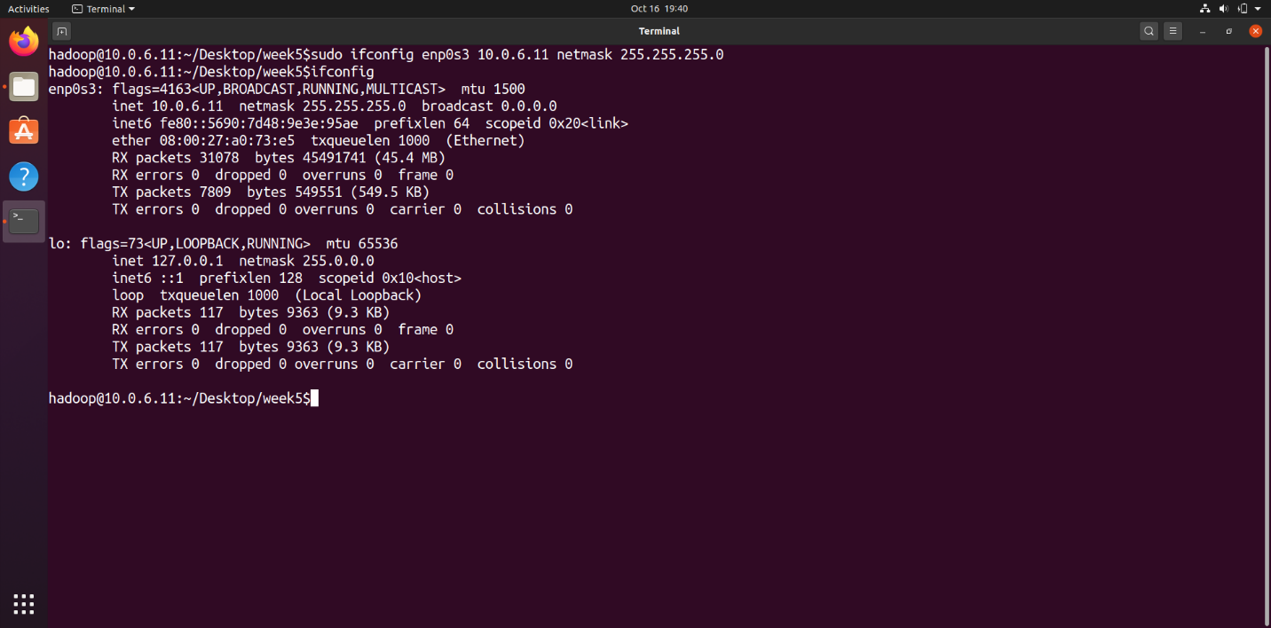

Server IP: set to 10.0.6.12

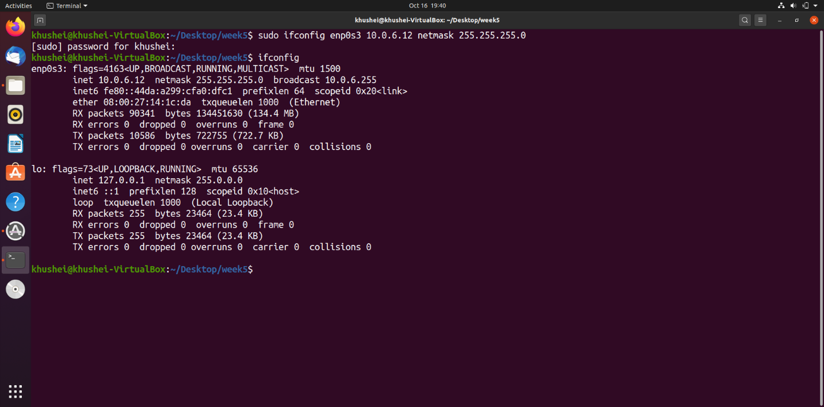

**Task 1:**

**Socket Programming with UDP**

Server:

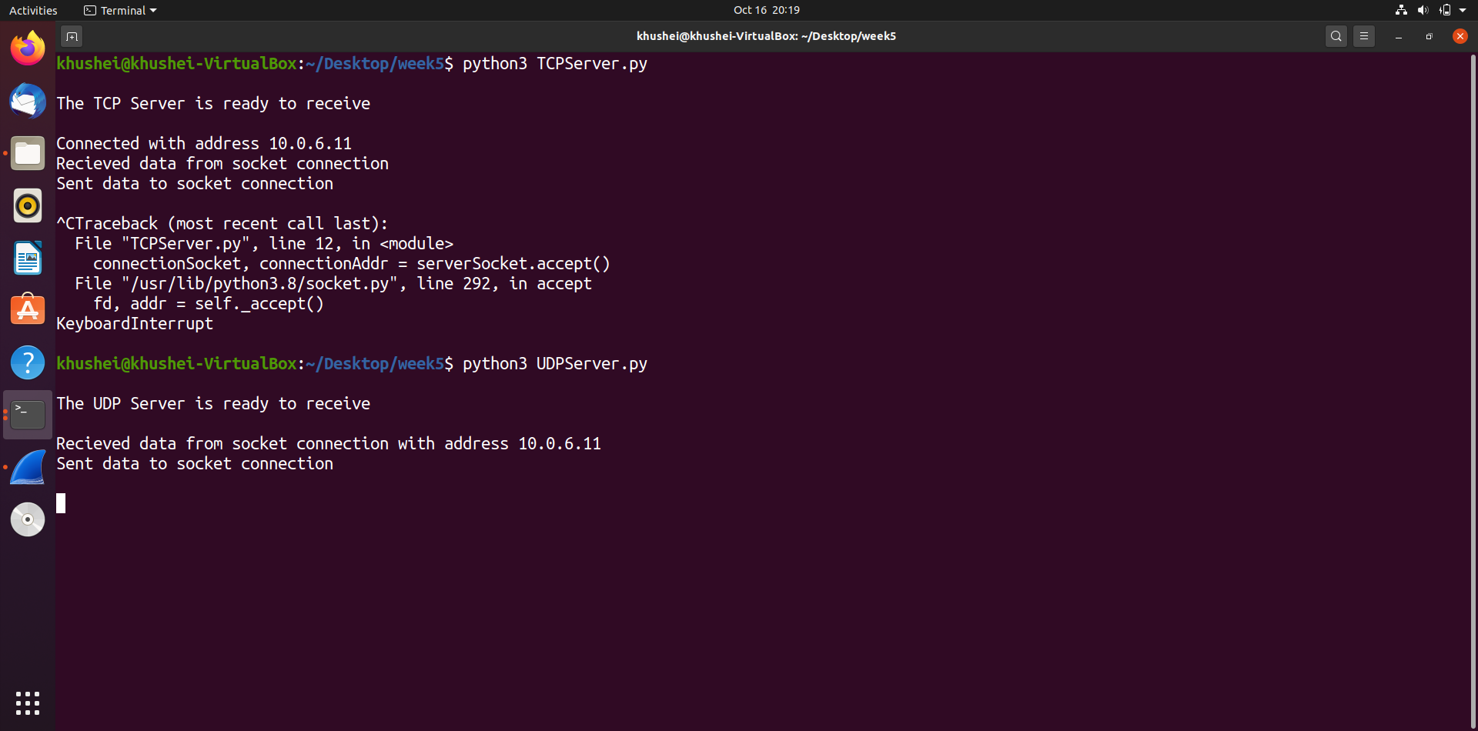

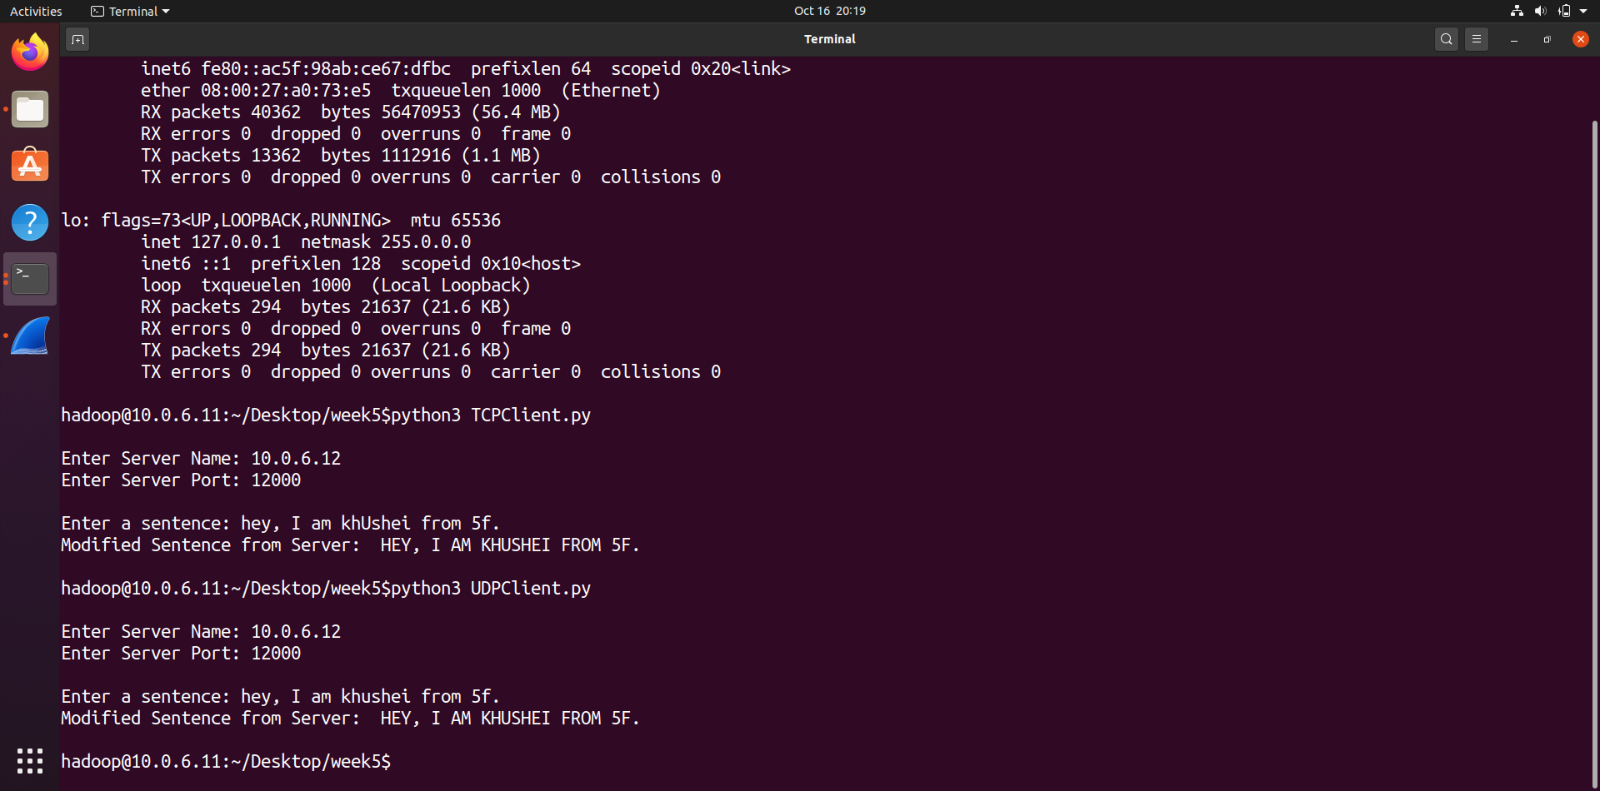Client:

Wireshark-

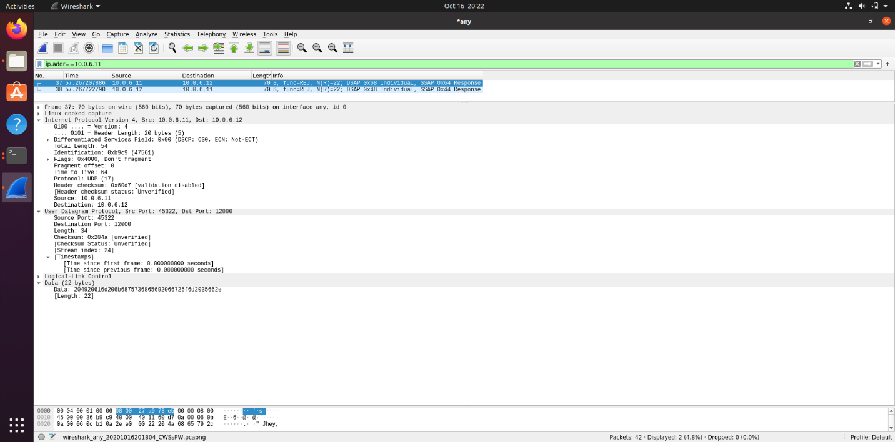

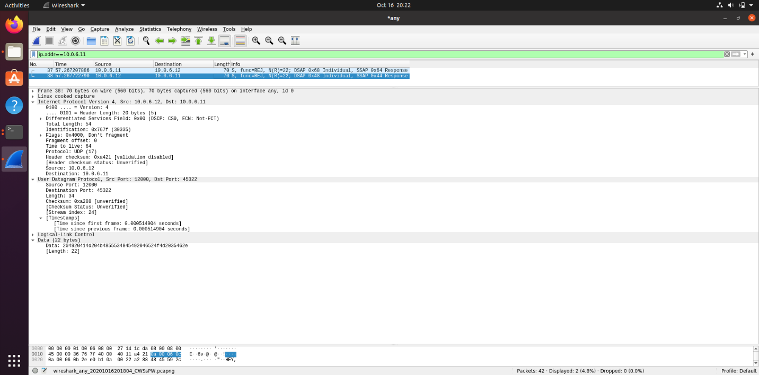

In UDP there is no handshaking process. The client attaches the server’s IP address and port number with each packet of data. The server extracts the client IP address and port number. It gets the data, converts it to upper case and sends it to the client.

**Socket Programming with TCP**

Server:

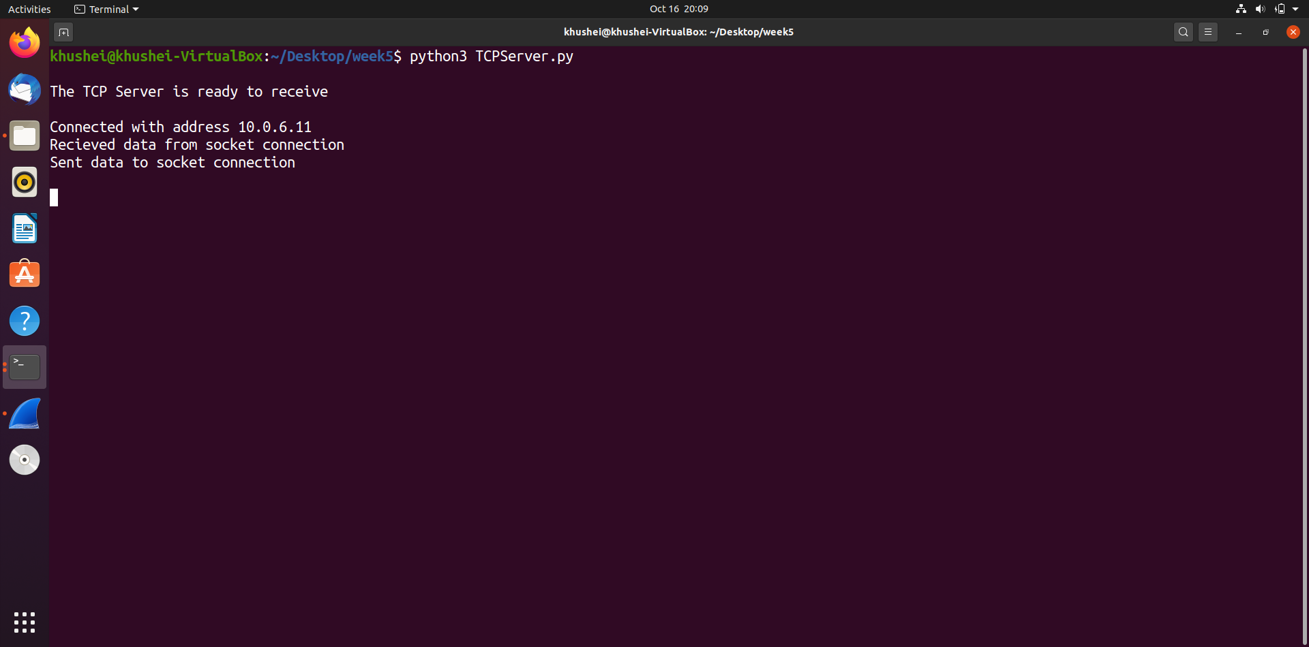

Client:

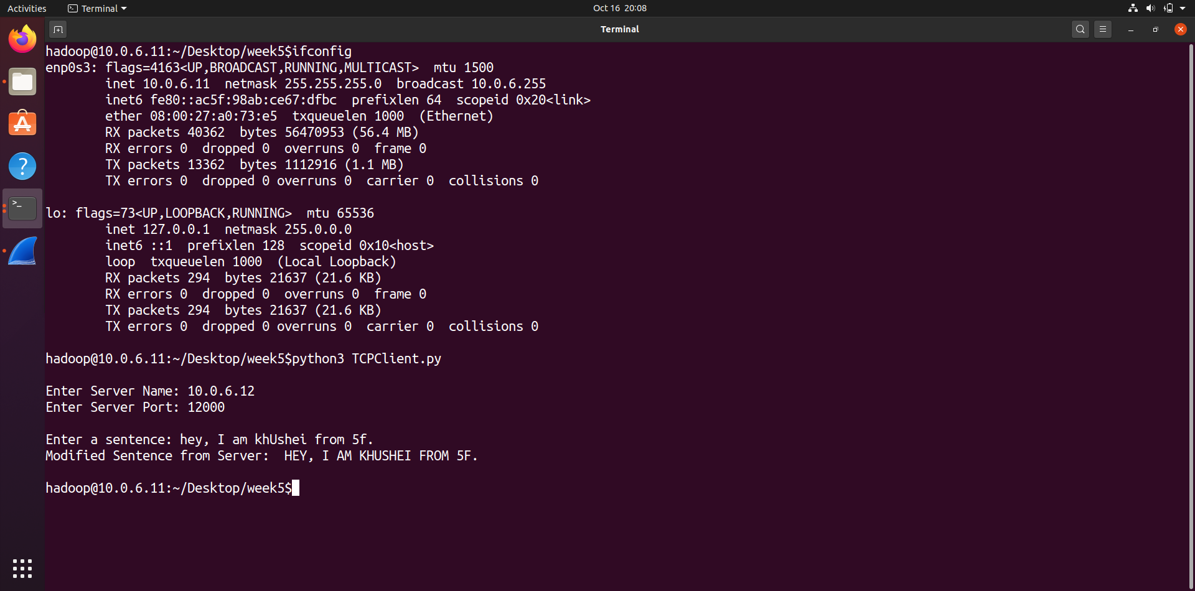

Wireshark-

SYN:

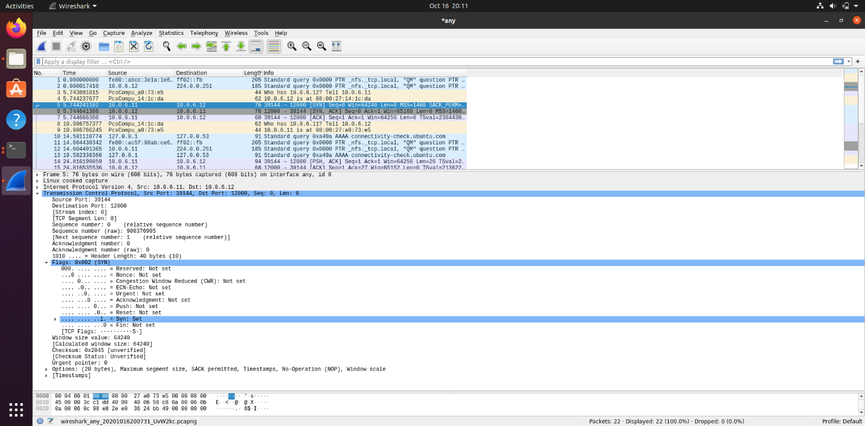

SYN ACK:

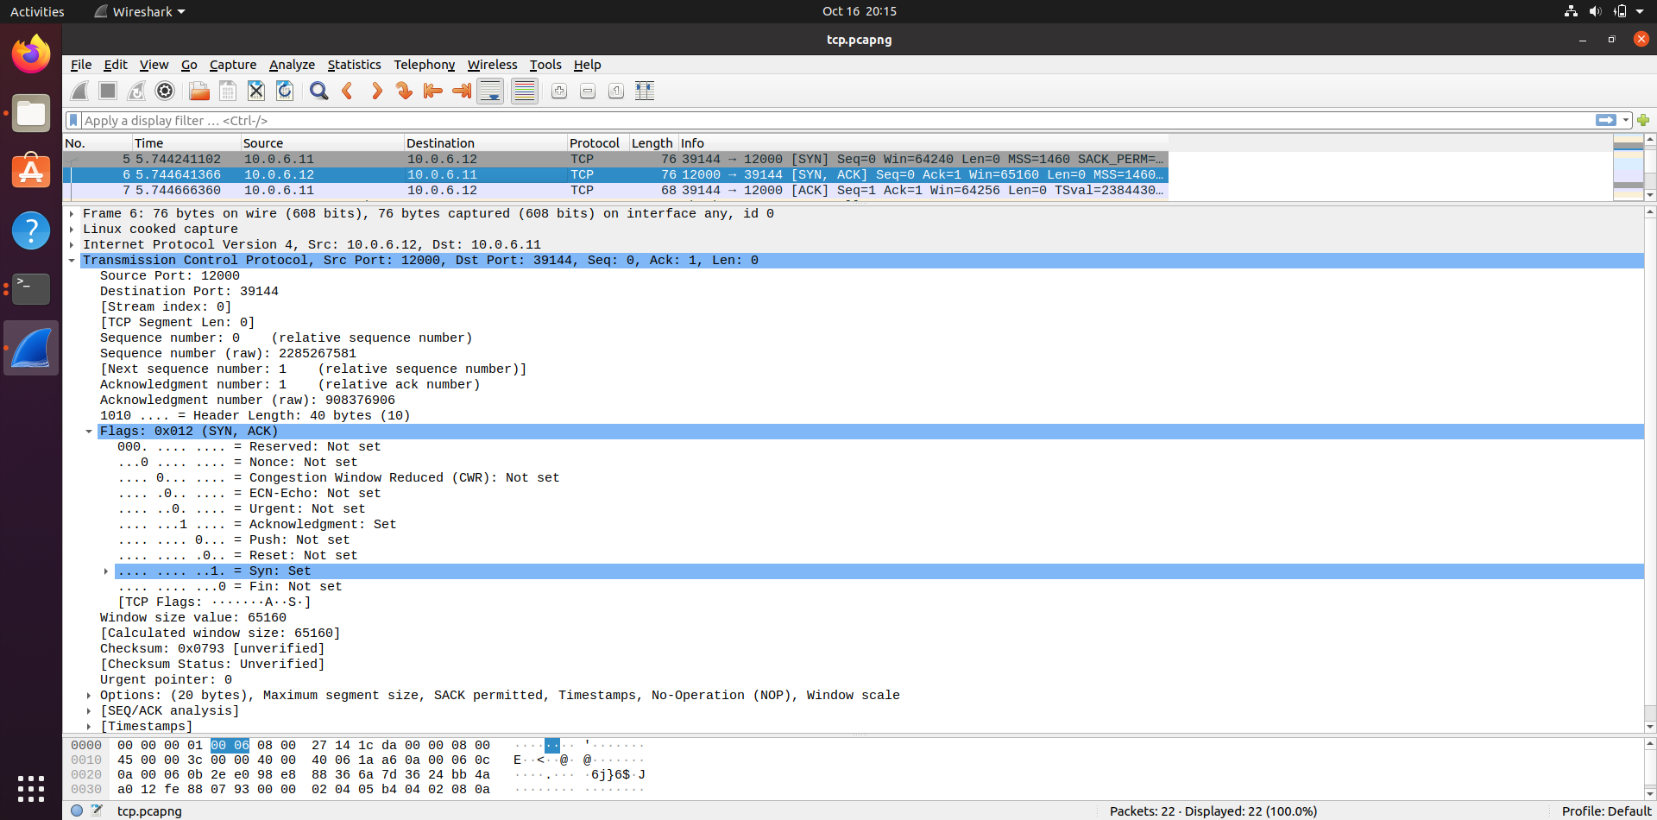

ACK:

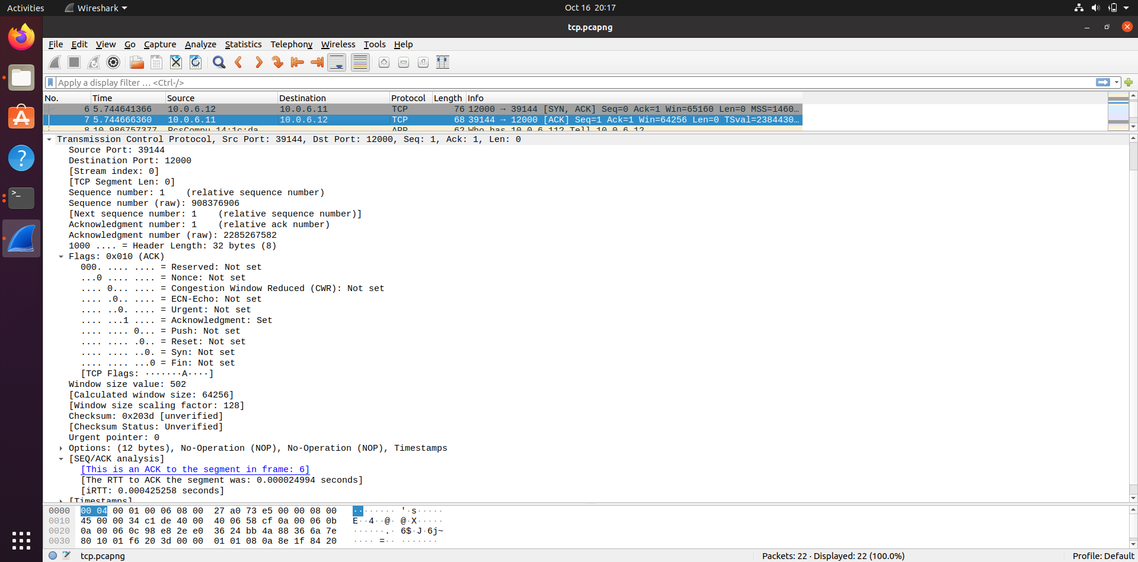

There is a three-way handshaking step to establish the TCP connection between the client and the server for which SYN and ACK packets are sent between the client and server as seen above.

Questions/Answers:

1. Suppose you run TCPClient before you run TCPServer. What happens? Why?

We get a ConnectionRefused error at the client side. This is because the server process is not running at this point of time and so when the client tries to establish connection with the server, it fails in doing so.

2. Suppose you run UDPClient before you run UDPServer. What happens? Why?

If we run the client program before the server, we do not get any error. We can enter a sentence as well, and the terminal keeps waiting for input without any errors.

3. What happens if you use different port numbers for the client and server sides?

The client tries to establish a connection with a non-existing or wrong process. This will result in an error.

**Task 3: Multi-Threaded Web Proxy**

For this task, I used only one vm and two terminals- one as client and other as server. I changed the vm’s IP address back to the original 10.0.2.4.

When [www.flipkart.com](http://www.flipkart.com) was requested the first time,

Client terminal-

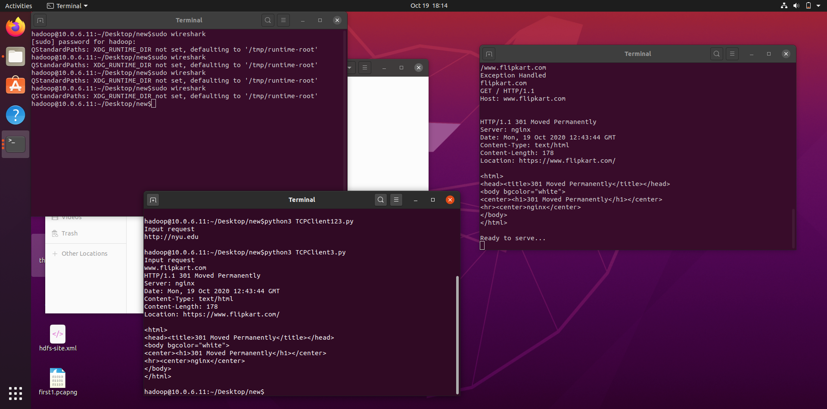

Server terminal-



Wireshark-

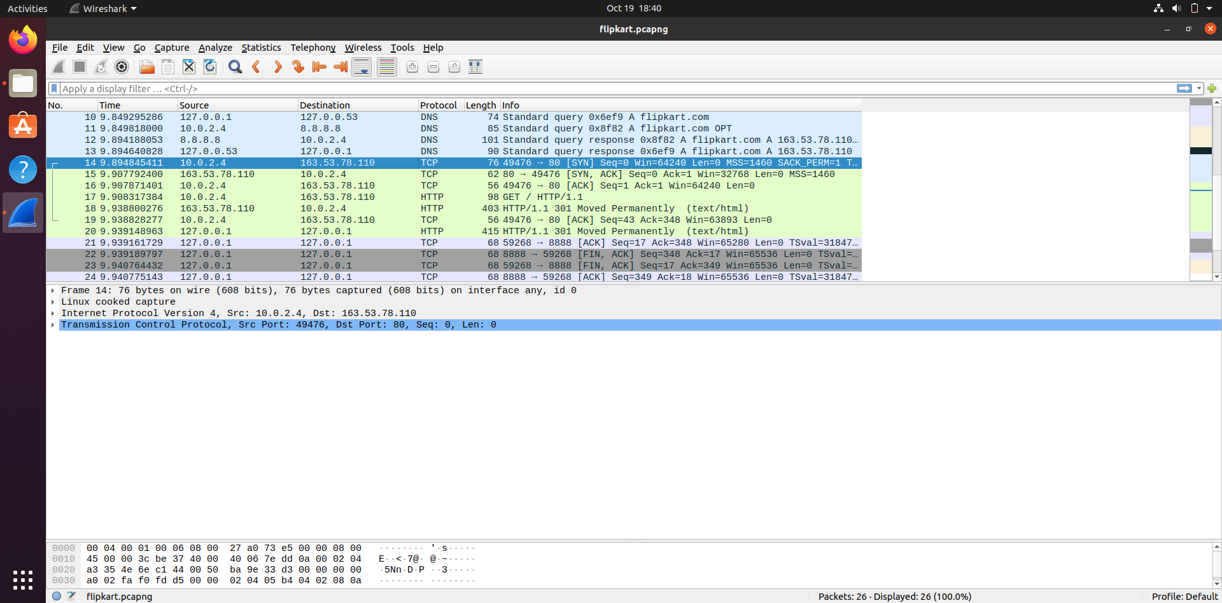

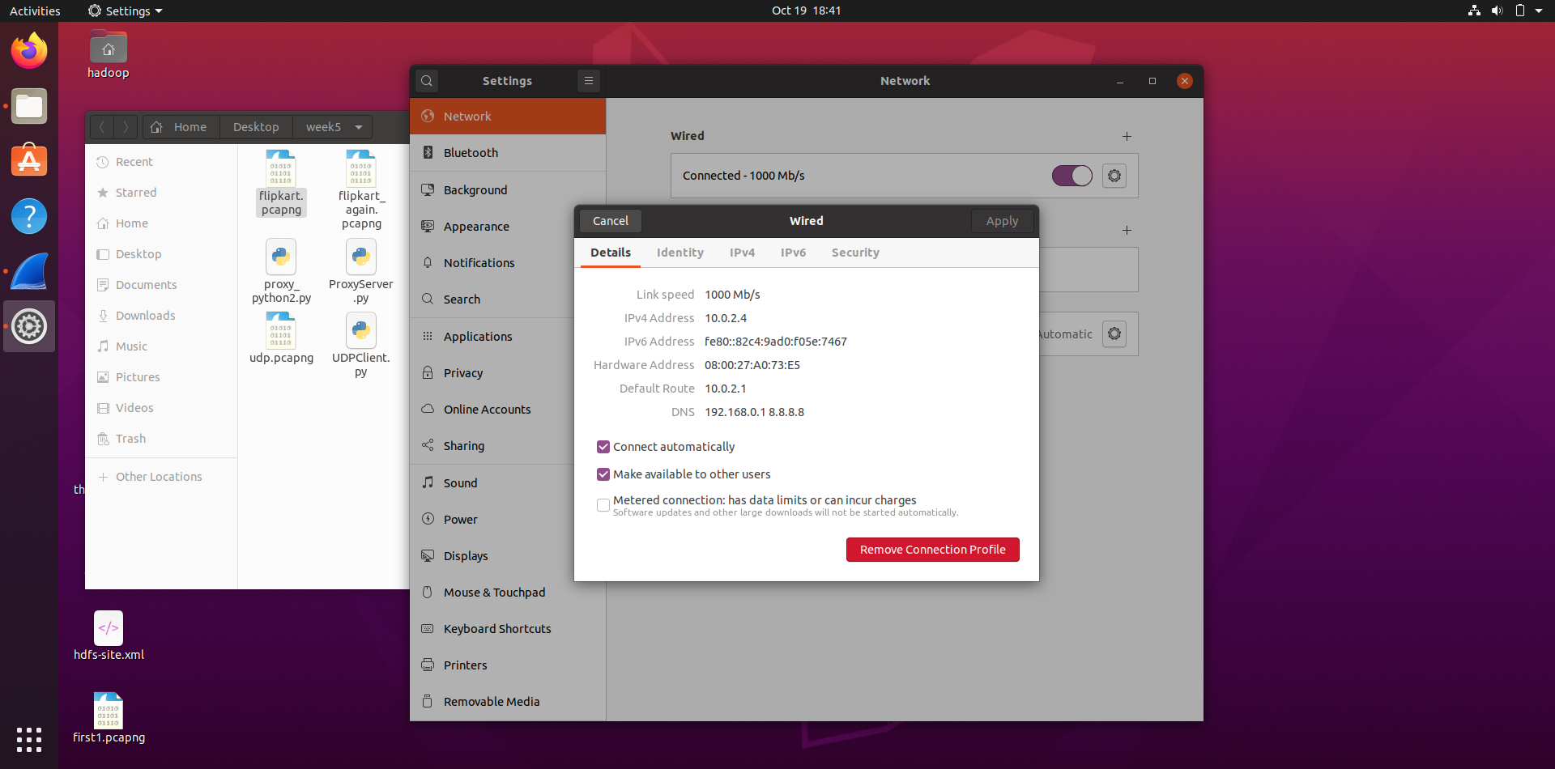

DNS request from 127.0.0.1 to 127.0.0.53. Notice the response come from 8.8.8.8 which is present as local DNS in the network settings as shown above. The same vm- 10.0.2.4 establishes a TCP connection with 163.53.78.110 ([www.flipkart.com](http://www.flipkart.com)). The request and response message interactions are between the same two IPs.

When we requested for [www.flipkart.com](http://www.flipkart.com) again from the client terminal, it was read from cache as can be seen in the server terminal’s screenshot.

Client-

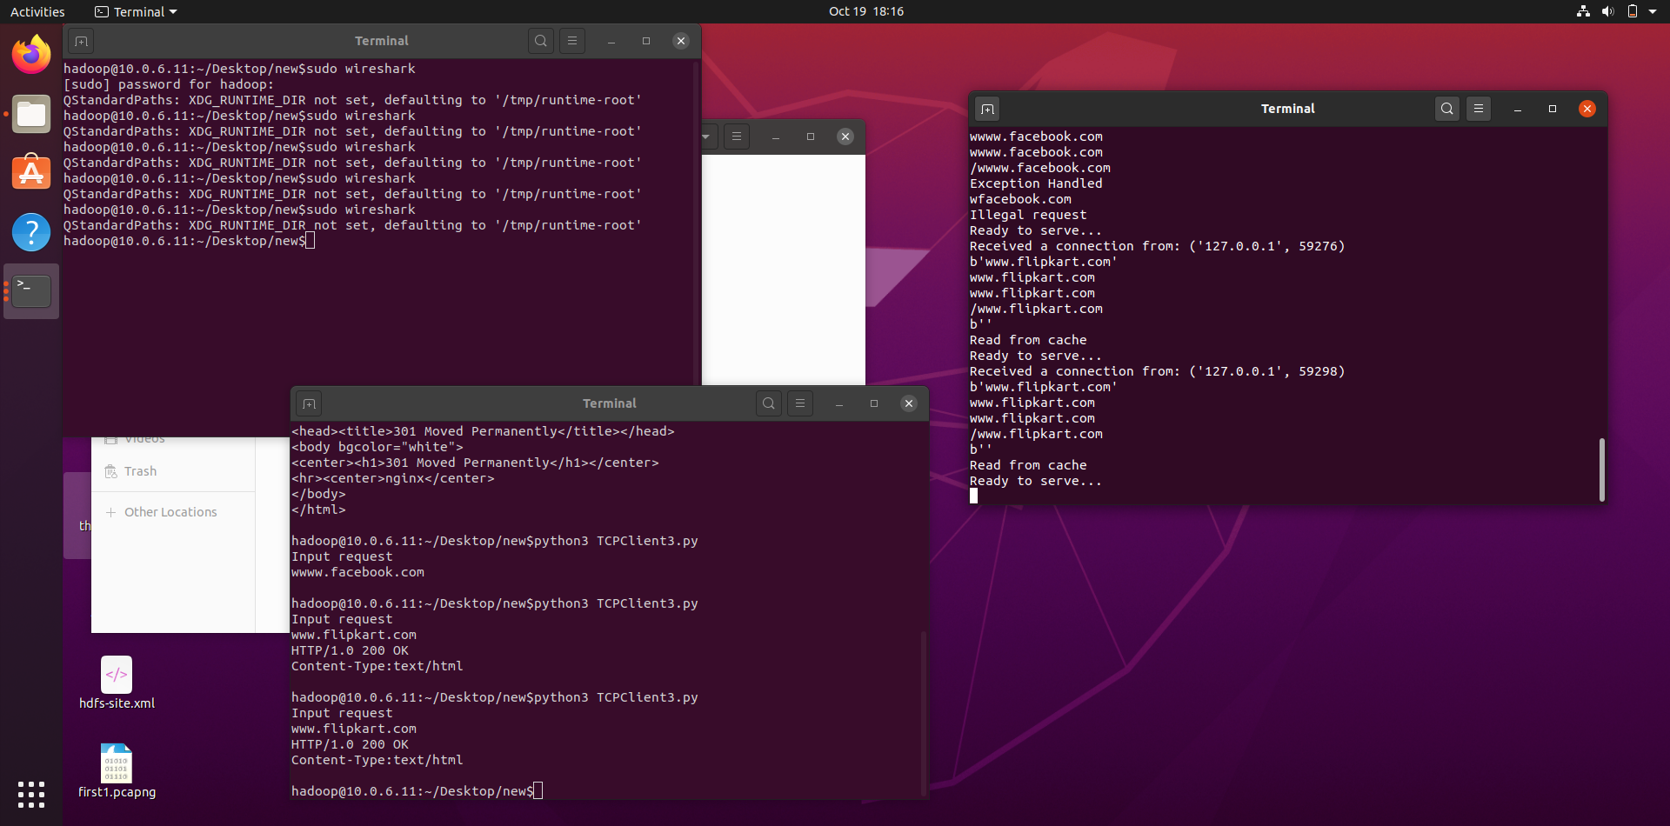

Server-



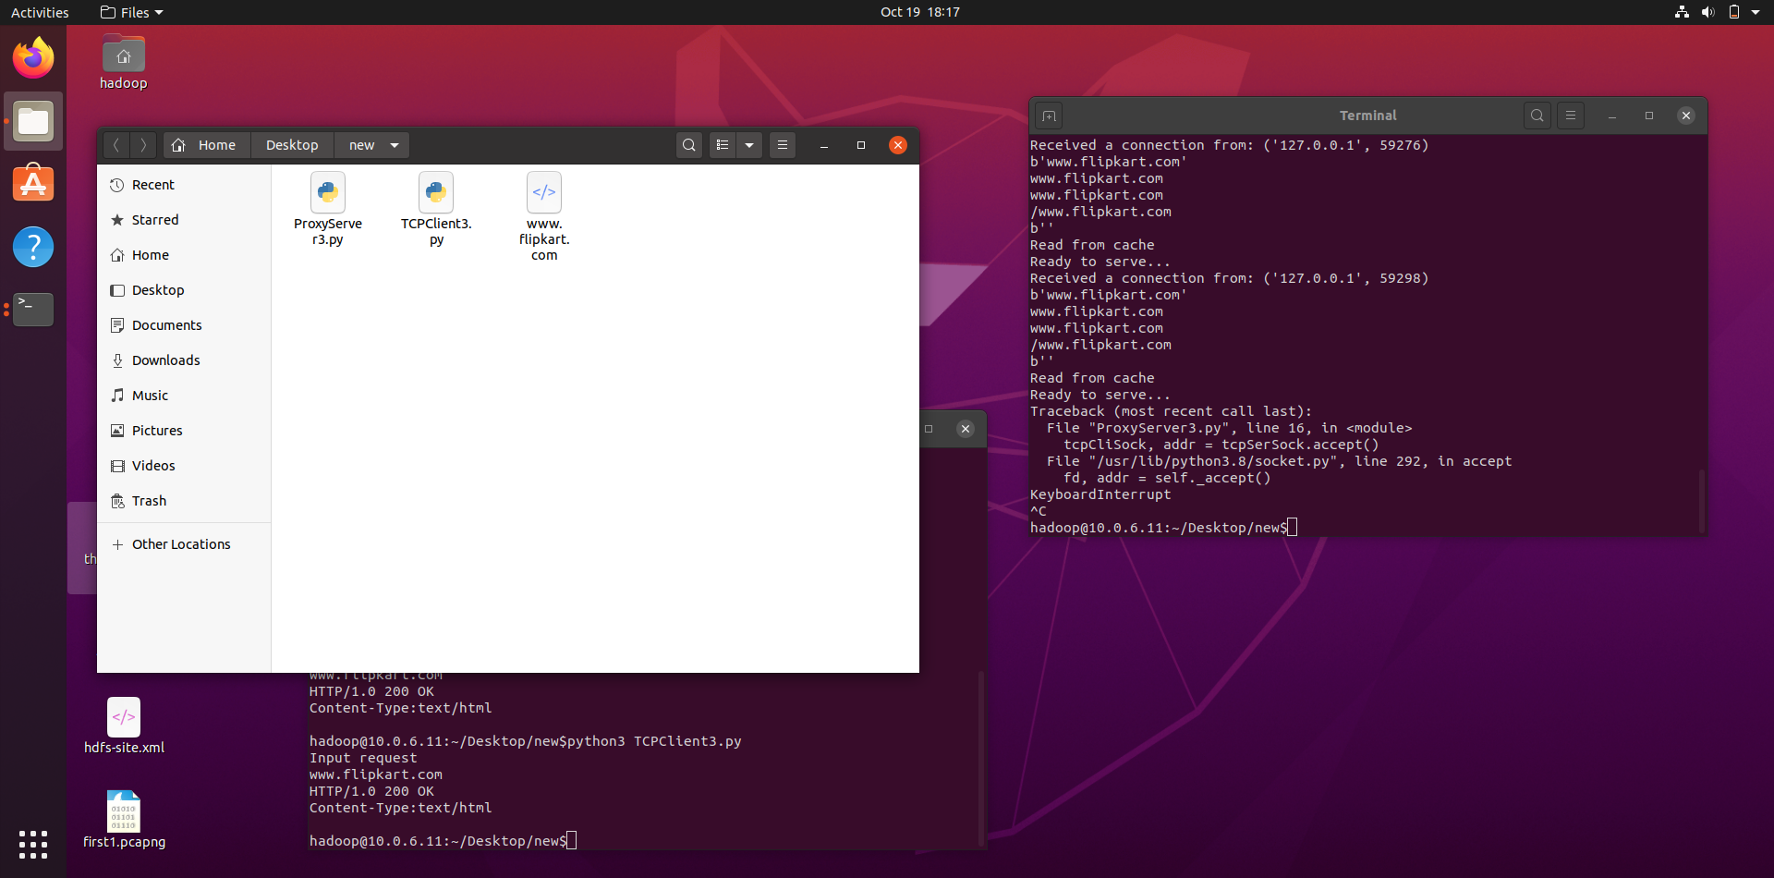

Wireshark-

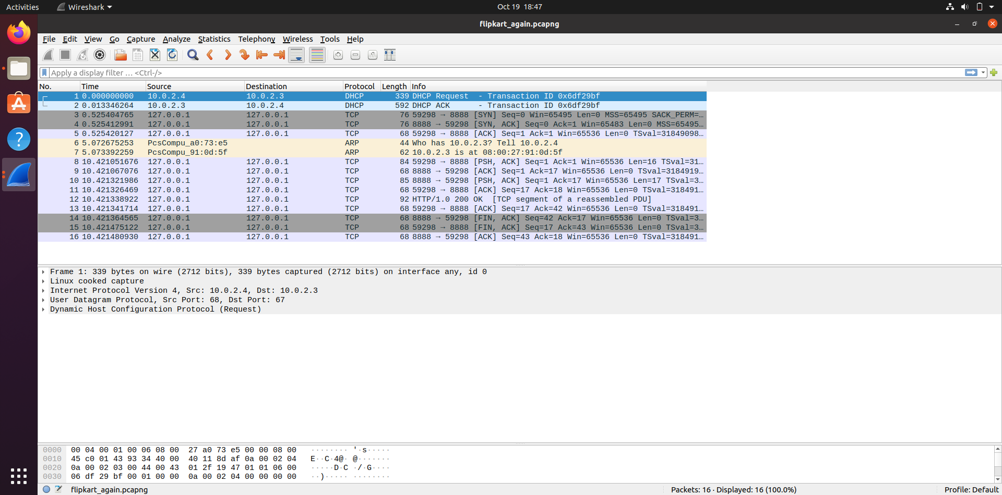

Notice that because of the caching step, the request doesn’t go to 163.53.78.110 ([www.flipkart.com](http://www.flipkart.com)).